**Operating Systems - Lab 06 Tasks**

Ibrahim Johar Farooqi

23K-0074

BAI-4A

05 March 2025

**Lab Questions:**

**Experiment 6a (Ordinary Pipe) :**

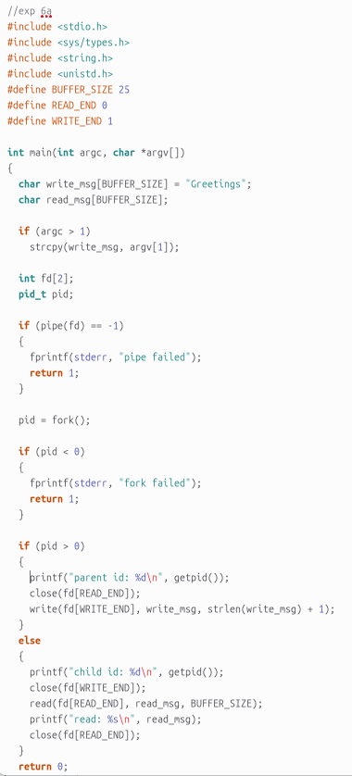

**Normal Pipe**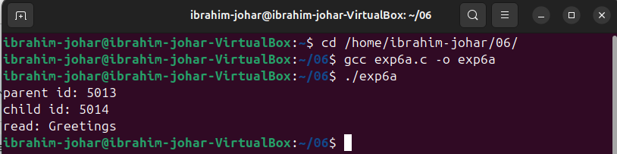

**Experiment 6b**

**Producer:**

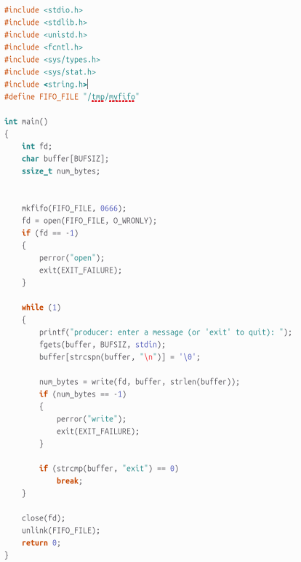

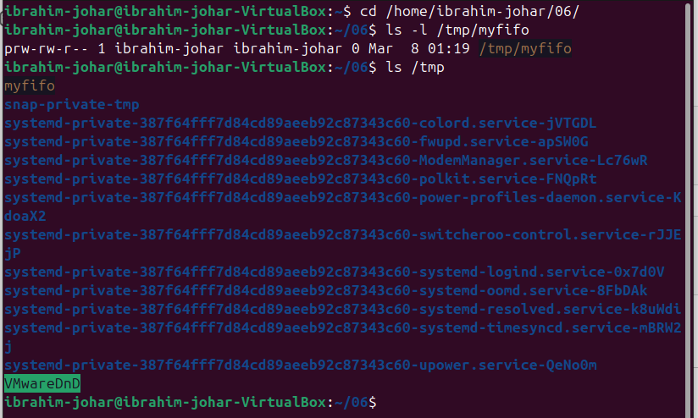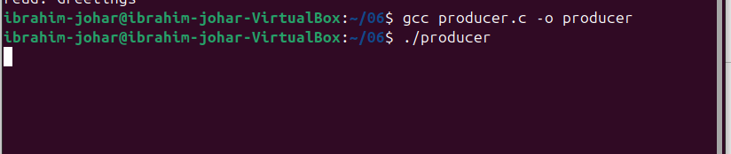

**Consumer:**



